SCHOOL OF ELECTRICAL, ELECTRONIC AND COMPUTER ENGINEERING
ENEL3SF –SOFTWARE ENGINEERING 2
GROUP 10
NAMES | STUDENT NUMBER
MARINDI MPHO | 223068894
RAMAKOPA KOKETSO | 224060934
ZULU BONGA | 224043843
ZWANE BANELE | 224006427
NGCOBO SIBONELO | 224007550

Table of Content
Introduction 2
1. Development Increment Scope and Requirements Coverage 3
Purpose of the Development Increment 4
Scope of the Increment 4
1.2 Requirements Coverage 4
1.3 System Architecture and Implementation 5
1.4 Frontend Implementation 5
1.5 Backend Implementation 6
1.6 Database Implementation 6
2. Core Prototype 6
3. Code Quality and Coding-Standard Compliance 9
4. Code Review Process and Evidence 12
5. Component Integration and Technical Implementation 13
5.1 Integration Objective 14
5.2 System Integration Architecture 14
5.3. How the frontend , backend database work together 14
System Overview 15
Figure 2 Backend Connection to PostgreSQL 15
Figure 3 Frontend Request to the Backend 16
Figure 4 Data Returned by the API 16
Figure 5 Database Record Created After an Application 17
Complete Request Flow 17
Reading Data — Figures 2, 3 and 4 18
Writing Data — Figure 5 18
Why the Three-Layer Design Works 18
5.4 Technical Components 19
5.4 Database Technical Implementation 19
5.5 Integration and Relationship Testing 20
User Account Test 20
Volunteer Profile Test 20
Opportunity Creation Test 21
Volunteer Skill Relationship Test 21
Opportunity Skill Relationship Test 22
Application Test 23
Multi-table Integration Query 23
Version-Control Integration Evidence 24
End-to-End Integration Flow 24
Current Integration Status 25
Technical Considerations 25
6. Integrated Minimum Viable Product 25
6.1 System Integration Overview 25
6.2 Step by step verification checklist 26
6.3 Manual end to end demo script 26
6.4 Main Risk Areas to Check if the System Fails 27
6.5 Current Limitations of the MVP 27
6.6.MVP Completion and verification criteria 28
7. Updated Documentation 28
8. Version Control, Defect Management and Development Discipline 29
Version Control 29
Defect Management 31
Development Discipline 32
9. Reflection and Technical Debt 33
Conclusion 33
References 34

Tables
Table 1: Scope of the increment 6
Table 2: Requirement Coverage 7
Table 3: Technical Components 22
Table 4 Integration Flow 27
Table 5: Verification Checklist 28
Table 6: Requirement traceability 31
Table 7: Defect and role 34
Table 8: Development 34

Table of figures
Figure 1: System Architecture 8
Figure 2: Volunteer system 10
Figure 3:The landing page for the organization's admin 10
Figure 4: Post opportunity 11
Figure 5: Admin opportunities 11
Figure 6: Dashboard 12
Figure 7:Backend API structure and modular implementation 14
Figure 8: Frontend source code structure of the Community Volunteer Coordination SystemThe frontend is divided into dedicated pages according to system functionality and user roles. Separate interfaces are provided for administrators and volunteers, while shared JavaScript and CSS files support application behavior and consistent presentation. 14
Figure 9: PostgreSQL database schema maintained in the project repository 15
Figure 10: Pull request created for API code review and input-validation improvementA pull request was created as part of the code-review process to evaluate changes before integration into the main branch. 16
Figure 11: Pull request created for Database 16
Figure 12: System Architecture 17
Figure 13: Implimantation 18
Figure 14: User Account Test 24
Figure 15: Volunteer Profile 25
Figure 16: Opportunity Creation 25
Figure 17: Volunteer Skill Relationship 26
Figure 18: Application Test 27
Figure 19: Multi-table Integration 27
Figure 20: Version Control Integration Evidence 28
Figure 21: Software code 34
Figure 22: Community Volunteering Software: Version 0.1 (core prototype) 34

Introduction
To enhance the way volunteers and organizations communicate and oversee community events, the Community Volunteer Coordination Platform was created. While organizations can develop opportunities, manage applications, and track volunteer involvement, the system offers a central platform where volunteers can build profiles, browse available opportunities, apply for activities, and manage their participation. A frontend, backend, and PostgreSQL database are used in the system's implementation. The database contains data about users, volunteer profiles, organizations, opportunities, apps, and talents; the frontend creates user interfaces; and the backend manages system requests and communication. The system's implementation, requirements of coverage, database design and testing, component integration, version control, and the development of a finished Minimum Viable Product are all covered in this report.

1. Development Increment Scope and Requirements Coverage

Purpose of the Development Increment
Moving the Community Volunteer Coordination Platform from design to execution is the aim of this development increment. The increment focuses on the essential features required for a Minimum Viable Product (MVP), especially volunteer-organization interaction.
The PostgreSQL database, backend/API layer, and frontend comprise the implemented solution. While the final backend integration is being finished so that the user interface may communicate with the database through API queries, the frontend interfaces and database structure have been implemented.

Scope of the Increment
Table 1: Scope of the increment
Component | Technology | Implementation | Status
Frontend | HTML, CSS, JavaScript | Registration, dashboards, opportunity pages, profiles, and applicant management. | Implemented
Backend | Server/API | Processes requests and communicates with PostgreSQL. | Integration being completed
Database | PostgreSQL 18 | Core tables, keys, relationships, and test data. | Implemented and tested
Version control | GitHub | Shared repository and integrated database schema. | Implemented

1.2 Requirements Coverage
User accounts, volunteer profiles, organization management, volunteer opportunities, applications, volunteer skills, and opportunity skills are all covered by the current increment. The platform's primary workflow consists of these features: an organization creates an opportunity, a volunteer views it and applies, and the organization can then examine the application.
Table 2: Requirement Coverage
Requirement | Frontend | Backend | Database | Evidence /Status
User accounts | Registration/login | Account processing | Users | Database support implemented
Volunteer profile | Profile/dashboard | Profile processing | Volunteer Profile | Database tested
Organization management | Admin interfaces | Organization processing | Organization; Organization  Member | Relationships tested
Create/view opportunities | Post/list/detail pages | Opportunity API | Opportunity | Inserted and retrieved
Applications | Sign-up/applicant UI | Application API | Application | Pending application inserted
Volunteer skills | Profile data | Skill processing | Skill; Volunteer Skill | Relationship tested
Opportunity skills | Opportunity data | Skill processing | Opportunity Skill | Relationship tested

1.3 System Architecture and Implementation
The architecture of the system is three layered. Information is displayed, and user actions are received by the frontend. Database operations and request processing are handled by the backend/API. Persistent project data is stored in PostgreSQL.

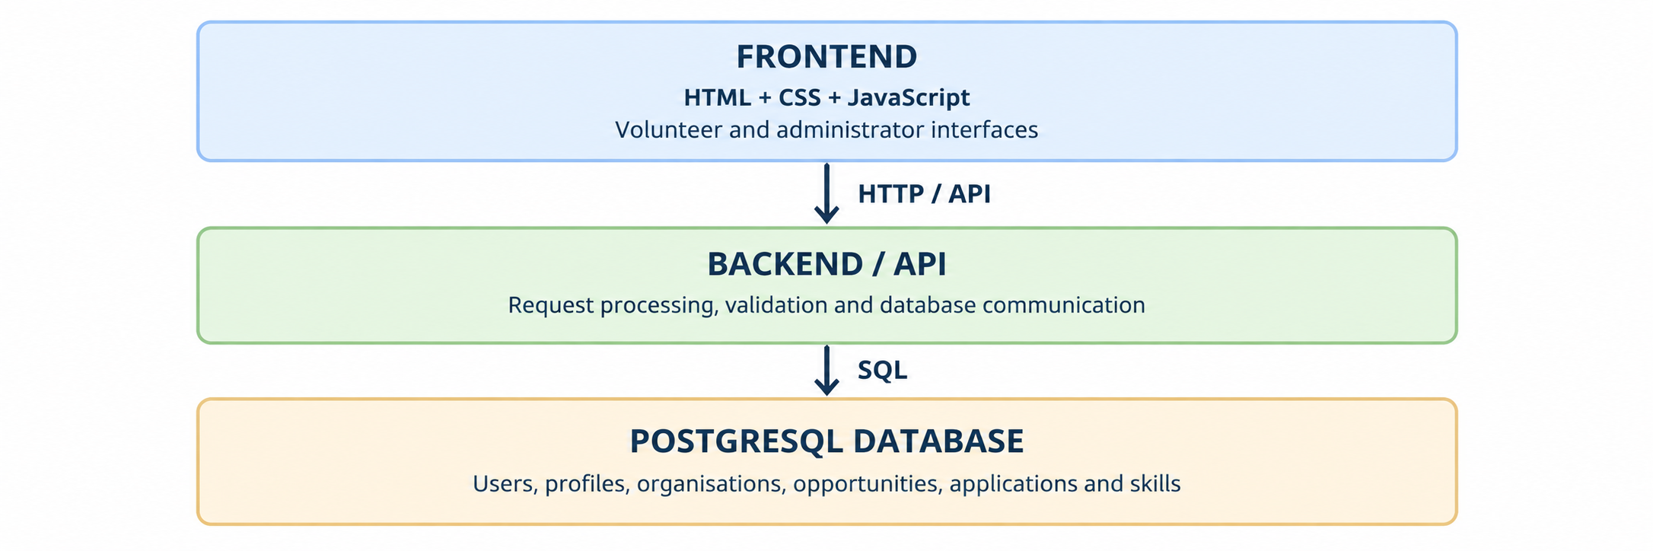
Figure 1: System Architecture

1.4 Frontend Implementation
The frontend is implemented as HTML pages that are backed by JavaScript and a shared CSS stylesheet. Registration, volunteer and administrator dashboards, opportunity listing and details, applicant management, profiles, and opportunity creation are among the sections that have been implemented. Additionally, prototype data and interactions that are linked to backend API calls upon final integration are included in the current JavaScript

1.5 Backend Implementation
The backend is the communication layer between the browser and PostgreSQL. It receives HTTP requests, validates data, performs database operations, and returns responses to the frontend. The team is completing this connection so that user actions on the interface create, retrieve and update real database records

1.6 Database Implementation
The implementation uses the community volunteer database on PostgreSQL 18. The verified core schema contains nine tables: Application, Opportunity, Opportunity Skill, Organization, Organization Member, Skill, Users, Volunteer Profile, and Volunteer Skill. Foreign keys to preserve relationships and junction tables support many-to-many associations.

2. Core Prototype
The core prototype of the Community Volunteer Coordination Platform builds upon the user-interface prototype submitted in the previous development increment. While the previous submission focused on the proposed interface and navigation, the current increment focuses on implementing the essential functionality required to demonstrate the system's main use cases.
The prototype supports two user roles: Volunteers and Organization Admins. Volunteers can browse available volunteering opportunities, view opportunity details, register for opportunities and manage their sign-ups. Organization Admins can create and manage opportunities and view volunteers who have registered for them.
The scope of the core prototype is limited to the essential features required to demonstrate the platform's main functionality. Additional features and refinements may be implemented in subsequent development of increments. The prototype will be evaluated through functional testing of the main user workflows, including opportunity creation, opportunity browsing and volunteer registration.
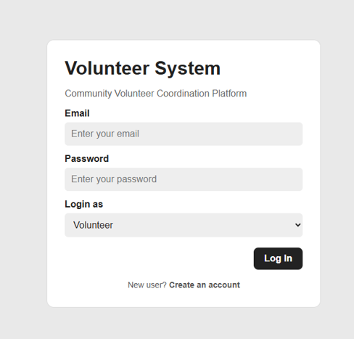
Figure 2: Volunteer system
The log in screen above is for both users to log in they can choose their role in the drop down so that system can direct them to their respective pages.
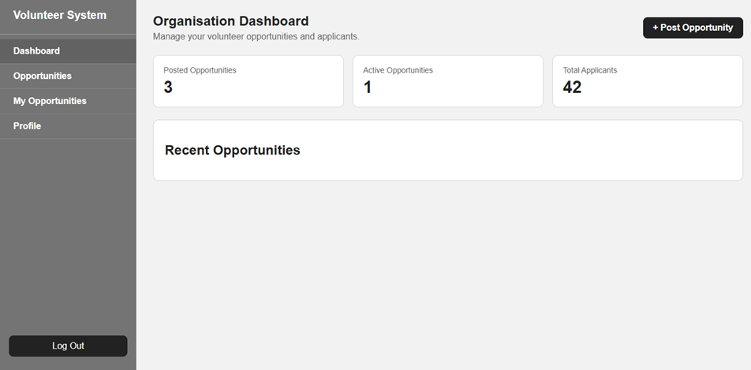
Figure 3:The landing page for the organization's admin
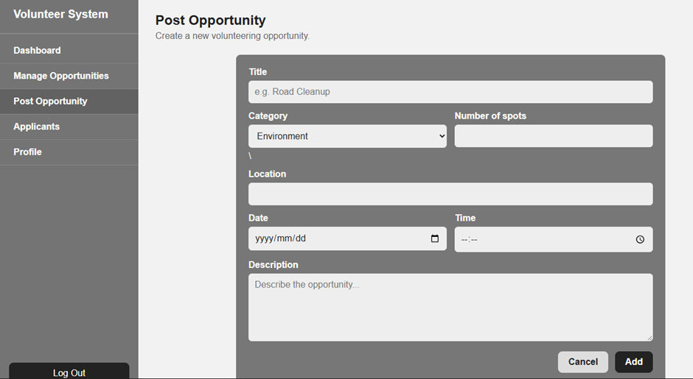
Figure 4: Post opportunity
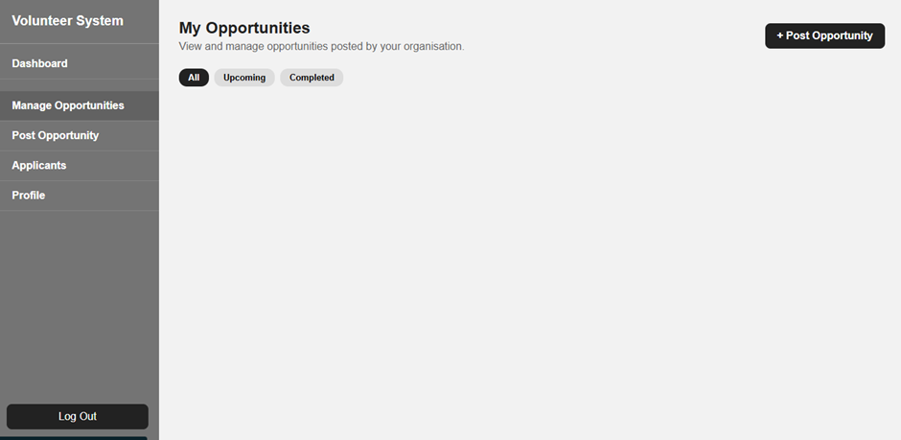
Figure 5: Admin opportunities
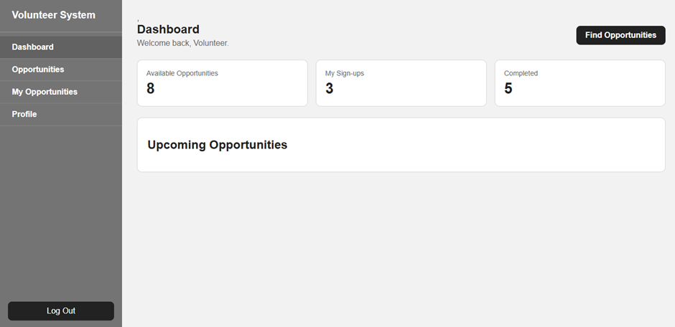
Figure 6: Dashboard

3. Code Quality and Coding-Standard Compliance
The Community Volunteer Coordination System was designed with the goal of creating code that is readable, maintainable, modular and consistent throughout the system. Coding standards were implemented for the frontend, backend API, and database to ensure that all components of the system could be integrated together effectively. The system has a modular architecture. The frontend component handles the presentation of the user interface to the users.
The Node.js and Express backend components handle the REST API endpoints that communicate with the PostgreSQL database. The database definitions and queries are separate from the user interface components. This separation of concerns allows for the reduction of unnecessary dependencies between components and makes maintenance easier in the future.
The application uses descriptive names for its files, variables, functions and API endpoints. The backend functionality is divided into route modules like authentication, opportunities, applications and notifications instead of having all the functionality in a single file. The reusable authentication and authorization functionality is implemented as middleware to reduce the amount of duplicated code within the application. The code has been formatted consistently throughout the file.
Input validation and error handling are incorporated into API operations. In the event that an invalid or incomplete request is made to the API, the API will return a response that shows the reason for the failure of the request. The API uses HTTP status codes such as 200, 201, 400, 401, 403, 404, 409, and 500 to show whether a request was successfully completed or if there was an error in processing the request.
In addition to considering code quality for the application, security was also considered. Passwords for users were handled using password hashing, JSON Web Tokens were used for authentication and authentication and authorization middleware was used for protected routes. Parameterized PostgreSQL queries are used when processing user-supplied information to reduce SQL-injection risks. Sensitive configuration information, including database credentials, is stored using environment variables, while.env and node modules are excluded from version control using .gitignore.

The database design supports code quality through clearly defined tables and relationships for users, opportunities, applications and notifications. Primary keys, foreign keys, unique constraints and appropriate data types are used to maintain data integrity.
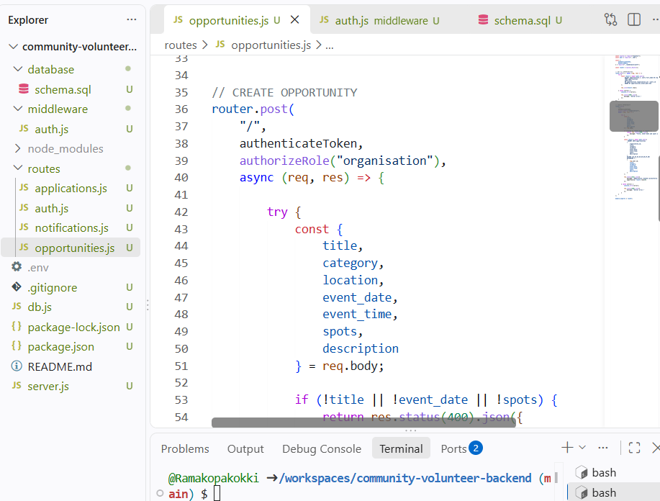
Figure 7:Backend API structure and modular implementation
The backend separates database configuration, authentication of middleware, database schema and API routes into dedicated components. This structure supports separation of concerns and makes individual components easy to maintain, test and integrate.
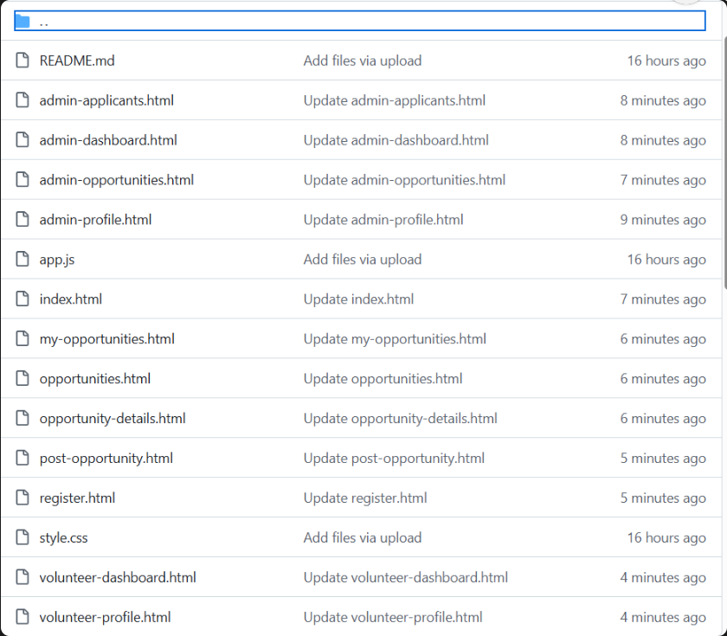
Figure 8: Frontend source code structure of the Community Volunteer Coordination SystemThe frontend is divided into dedicated pages according to system functionality and user roles. Separate interfaces are provided for administrators and volunteers, while shared JavaScript and CSS files support application behavior and consistent presentation.

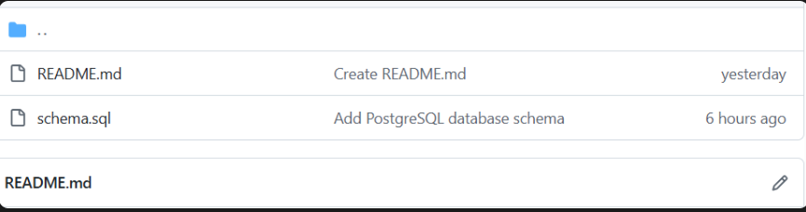
Figure 9: PostgreSQL database schema maintained in the project repository
The database component of the Community Volunteer Coordination System is maintained using a PostgreSQL schema stored in schema.sql.

4. Code Review Process and Evidence
Code review was used as part of the development process to improve consistency and identify problems before components were incorporated into the integrated Community Volunteer Coordination System. Because different team members were responsible for different components, review was particularly important for ensuring that independently developed code followed correct structures and the correct required interfaces.
The review process focused on the frontend functionality, backend API implementation, database interaction and integration between different components. The team checked code for readability, consistent naming, duplicated logic, input validation, error handling, security issues and if it complies with the agreed system design.
Authentication and authorization were both reviewed because they protect system functionality. Protected API operations require authentication, and role-based access control distinguishes actions available to volunteers from those available to organization users.
Where problems are identified during review, they should be corrected and the affected functionality must be tested again before integration. Examples may include incorrect route paths, inconsistent variable names, missing validation, incorrect database fields, duplicated functionality or integration mismatches.

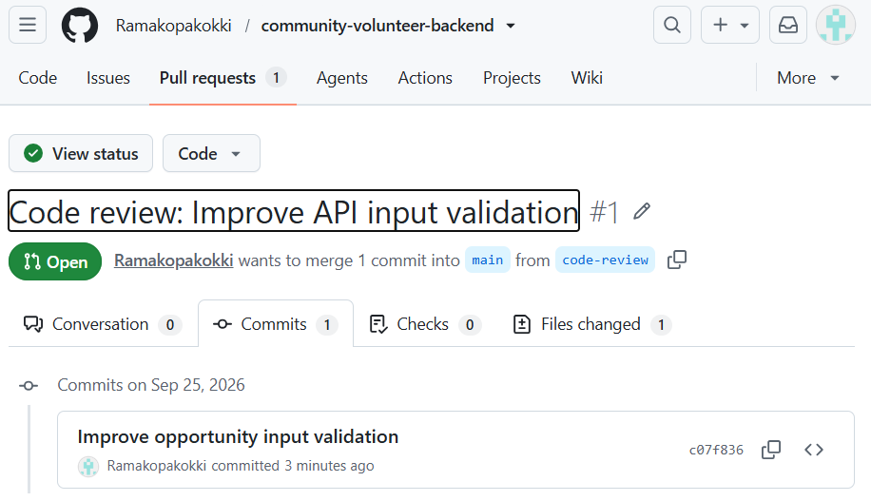
Figure 10: Pull request created for API code review and input-validation improvementA pull request was created as part of the code-review process to evaluate changes before integration into the main branch.
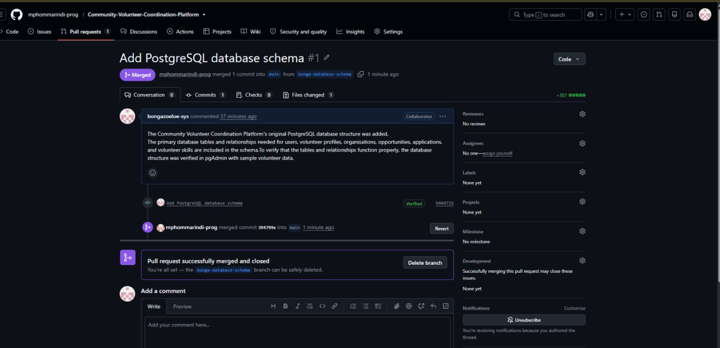
Figure 11: Pull request created for Database

5. Component Integration and Technical Implementation

5.1 Integration Objective
Connecting the frontend, backend/API layer, and PostgreSQL database to enable the platform to function as a single system is the goal of component integration. User contact is handled by the frontend, system logic is applied and requests are processed by the backend, and persistent project data is stored in PostgreSQL

5.2 System Integration Architecture
The path of integration is illustrated below. User activities start in the browser, travel to the backend via HTTP/API requests, and convert into PostgreSQL database for SQL operations. After that, the frontend receives the results via the backend.
Figure 12: System Architecture

5.3. How the frontend, backend database work together
This section describes how the three main parts of the system the frontend, backend, and PostgreSQL database communicate with one another. The figures demonstrate how a request moves through these components, from the user's browser to the database and back.
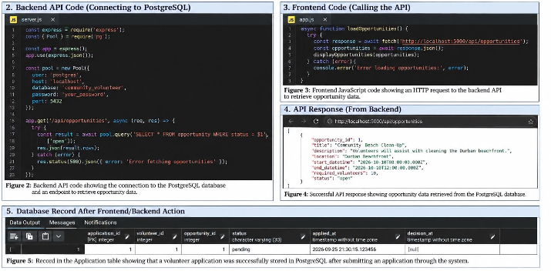
Figure 13: Implimantation

System Overview
The application follows a three-layer structure, with each layer responsible for a specific task:
Layer | Main Responsibility
Frontend | Collects information from users and presents data in the browser
Backend | Handles requests, performs validation, and communicates with the database
PostgreSQL Database | Stores the application's information permanently
Communication takes place between adjacent layers. The frontend does not connect directly to PostgreSQL, and the database does not communicate directly with the frontend. The backend acts as the middle layer between them.
Frontend → Backend → PostgreSQL Database
← ←
This structure makes the system easier to maintain because each layer can be modified, tested, or replaced without requiring major changes to the other layers.

.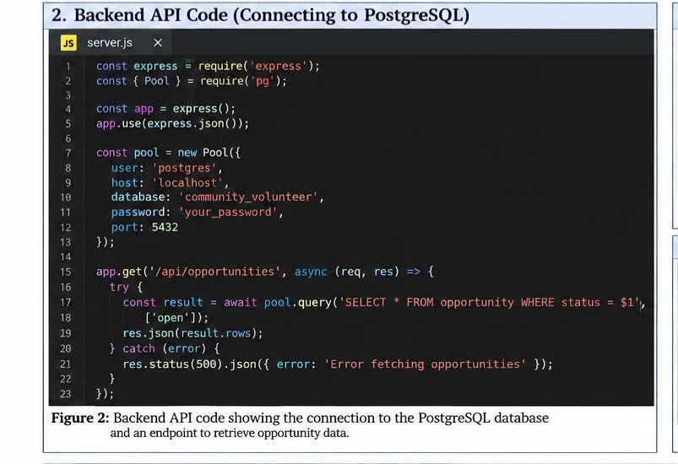
Figure 2 demonstrates how the backend, through server.js, connects to the PostgreSQL database.
The file performs two main functions. First, it creates a connection pool containing the information required to access the database, including the host (localhost), database name (community_volunteer), username, password, and PostgreSQL port (5432). This provides the backend with the details needed to establish a database connection.
Second, the file defines the /api/opportunities endpoint. When this endpoint receives a request, the backend executes a SQL query on the opportunity table and retrieves records whose status is "open". The results are then returned to the frontend in JSON format.
This figure demonstrates that the backend has successfully connected to PostgreSQL and is able to retrieve information from the database.

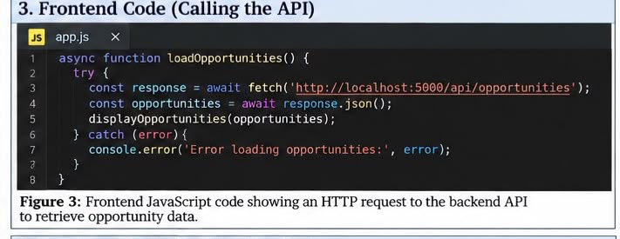
Figure 3 shows the frontend code in app.js, which runs in the user's browser. The fetch() function is used to send an HTTP request to http://localhost:3000/api/opportunities, which corresponds to the API endpoint defined by the backend.
Once the backend responds, response.json() converts the returned data into a JavaScript object that the frontend can process and display.
This demonstrates that the frontend can communicate successfully with the backend. Importantly, the frontend does not need to know how or where the database is stored; it only communicates with the backend through the API endpoint.

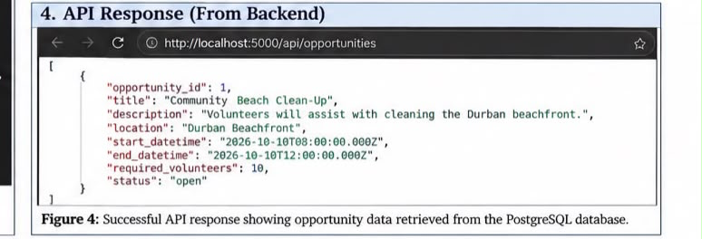
Figure 4 displays the JSON response returned by the backend, as seen in the browser's developer tools. The response contains an array with one opportunity:
[
{
"opportunity_id": 1,
"title": "Beach Cleanup",
"location": "Durban Beach",
"required_volunteers": 50,
"status": "open"
}
]
The response demonstrates that:
- The backend successfully retrieved information from PostgreSQL.
- The database query correctly returned only opportunities with a status of open.
- The JSON response contains the fields required by the frontend.
The square brackets [ ] indicate that the response is an array of records. Therefore, the same structure is returned even when only one opportunity is found
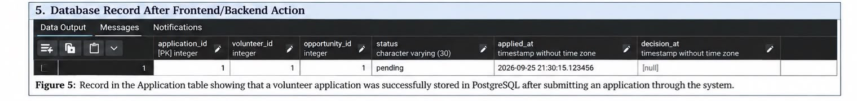
Figure 5 shows the application table in pgAdmin after a volunteer selects the Apply button. The action creates a new record in the database:
application_id | volunteer_id | opportunity_id | status | applied_at | decision_at
1 | 1 | 1 | pending | 2026-09-25 23:15:33 | null
Several important details can be observed:
- application_id is the primary key (PK), and PostgreSQL automatically generates its value. The backend therefore does not need to manually assign the ID.
- status is set to pending, indicating that the application has been submitted but a final decision has not yet been made.
- decision_at remains null, showing that the organisation has not yet approved or rejected the application.
This figure demonstrates that an action performed by the user through the frontend results in a permanent record being stored in the database.

Complete Request Flow
When the figures are considered together, they demonstrate the complete communication process between the three layers.

Reading Data Figures 2, 3 and 4
- The user opens the opportunities page.
- The frontend sends a request to /api/opportunities.
- The backend receives the request and queries the opportunity table.
- PostgreSQL returns the matching records to the backend.
- The backend converts the results into a JSON response.
- The frontend receives the response and displays the opportunities.

Writing Data Figure 5
- The user selects Apply for an opportunity.
- The frontend sends the application request to the backend.
- The backend validates the request and creates a new record in the application table.
- PostgreSQL stores the record and automatically generates its primary key.
- The newly created application is stored with a pending status.

Why the Three-Layer Design Works
Communication between the three components depends on several agreed structures:
Agreement | Components Involved | Example
API endpoint URLs | Frontend ↔ Backend | /api/opportunities
JSON field names | Backend ↔ Frontend | opportunity_id, title, status
Database schema | Backend ↔ PostgreSQL | application table and status column
These agreements provide a consistent interface between the different layers. As long as the API endpoints, JSON structures, and database schema remain compatible, each layer can be developed and tested independently. The figures in this section provide practical evidence that the communication between the frontend, backend, and database is functioning correctly.

5.4 Technical Components
Table 3: Technical Components
Component | Technical role | Current implementation
Frontend | Collects user input and displays system data. | HTML, CSS and JavaScript pages for volunteer and administrator functions.
Backend/API | Receives HTTP requests, validates input, performs database operations and returns responses. | Being completed against the PostgreSQL schema.
PostgreSQL Database | Stores users, volunteer profiles, organizations, opportunities, applications and skills. | Implemented and tested in pgAdmin.
GitHub | Provides shared version control and integration of team contributions. | Database schema merged into the shared main branch.

5.4 Database Technical Implementation
The project uses the PostgreSQL 18 database community volunteer. Nine tables Application, Opportunity, Opportunity Skill, Organization, Organization Member, Skill, Users, Volunteer Profile, and Volunteer Skill make up the confirmed core schema. Junction tables show many-to-many relationships, foreign keys preserve relationships, and primary keys identify records.

5.5 Integration and Relationship Testing
The following pgAdmin tests verify that the database component can support the integrated system. Each screenshot is an actual test performed during implementation

User Account Test
A prototype volunteer account with an email address, password hash, and volunteer job was added to the user's database to test it. The test verified that the system can accurately store user account data and provide a distinct User ID on its own
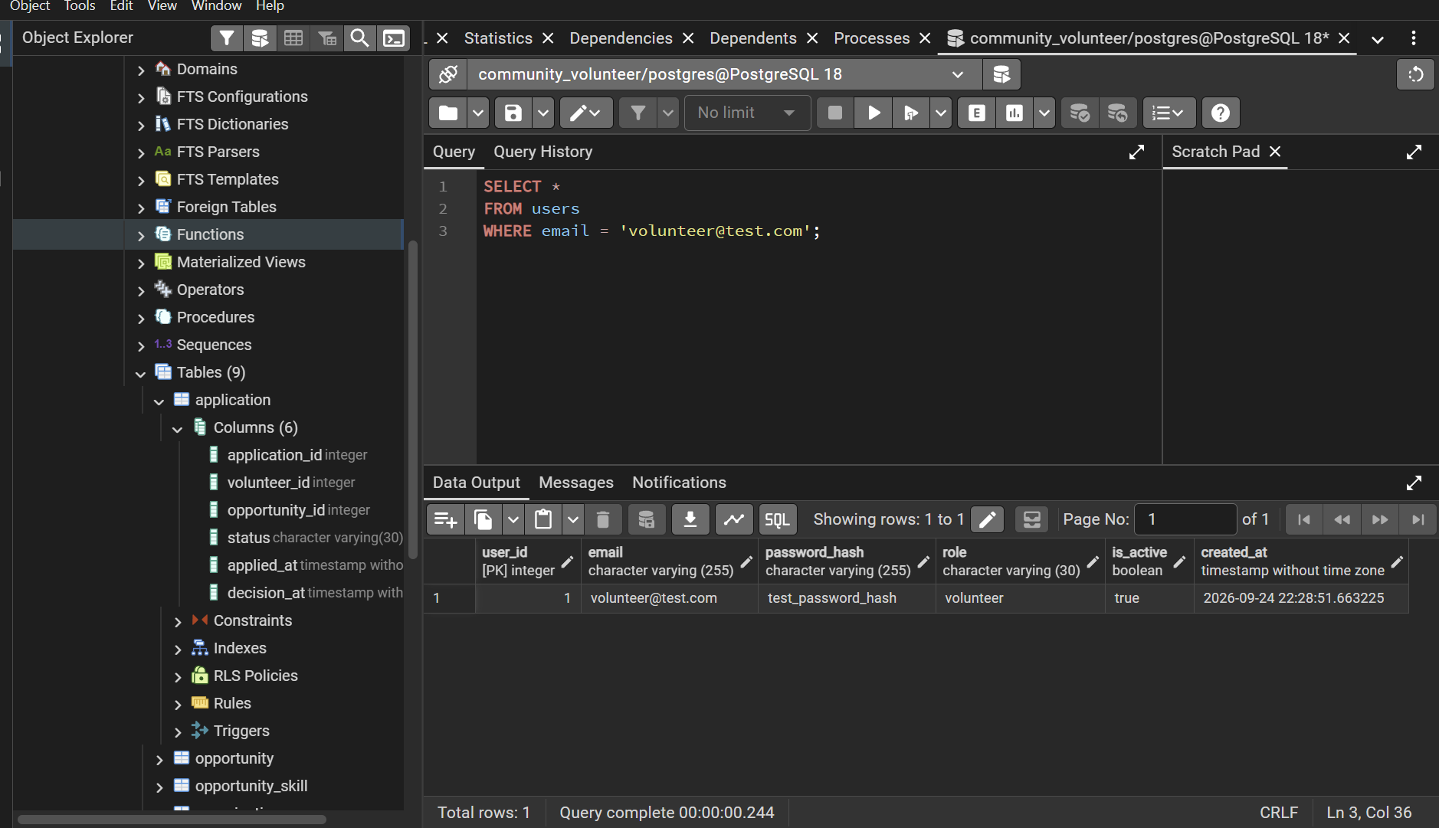
Figure 14: User Account Test

Volunteer Profile Test
The volunteer's personal information, such as name, phone number, location, and availability, was then stored in the volunteer profile database using the same User ID. The successful outcome verified that the Users table and Volunteer Profile table's foreign-key relationship is operating as intended
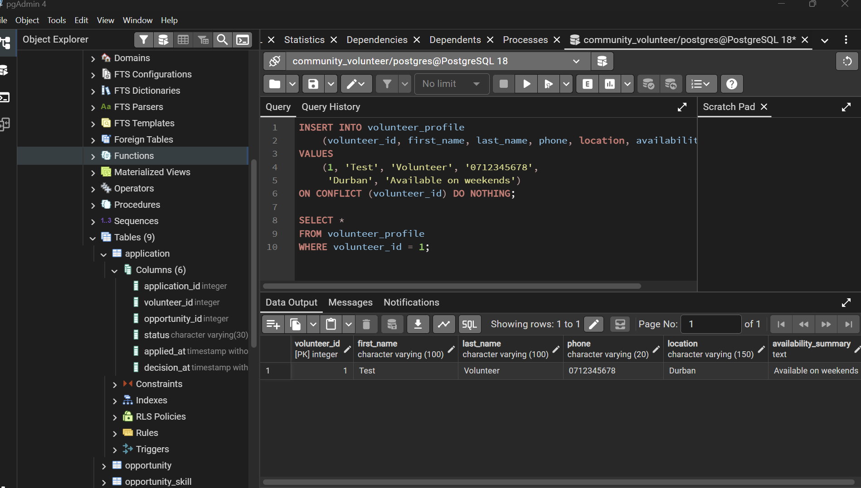
Figure 15: Volunteer Profile

Opportunity Creation Test
The option to clean up the community beach was successfully added. This confirms that the organization's reference, title, description, location, date/time, necessary volunteers, and status are all stored in the Opportunity table.
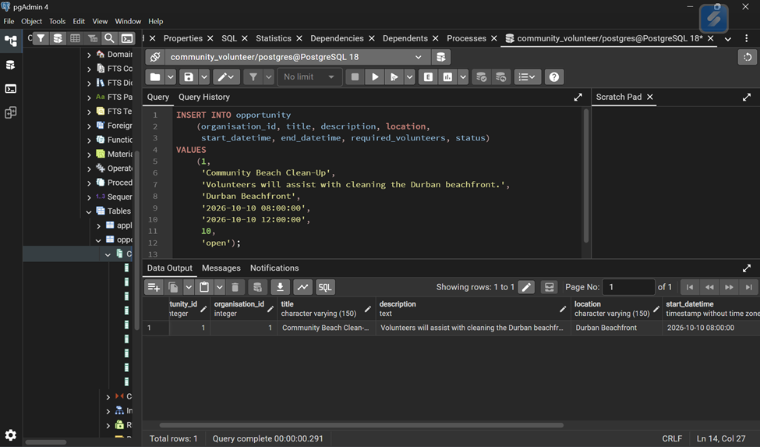
Figure 16: Opportunity Creation

Volunteer Skill Relationship Test
The Volunteer Skill junction table was used to connect Volunteer 1 to Skill 1. This demonstrates that volunteers and skills have a many-to-many relationship.
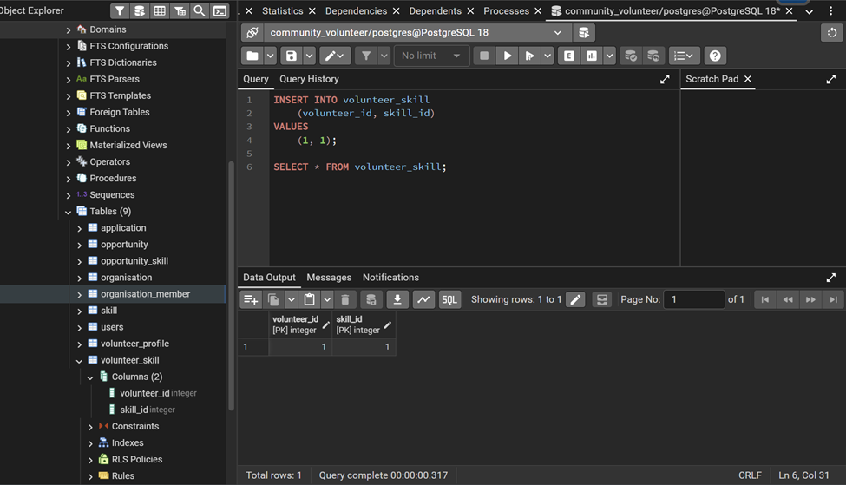
Figure 17: Volunteer Skill Relationship

Application Test
For Volunteer 1 and Opportunity 1, a pending application was added. Decision At is null since the application has not yet been approved or denied, but the produced application ID and applied-at date attest to successful storage
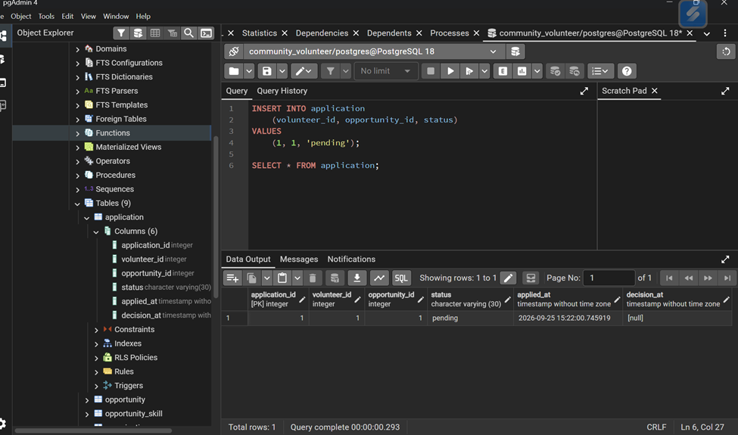
Figure 18: Application Test

Multi-table Integration Query
The volunteer, opportunity, organization, application status, and timestamp were all returned in a single result via a JOIN across Application, Volunteer Profile, Opportunity, and Organization. This is compelling proof that the database relationships that have been built function properly.
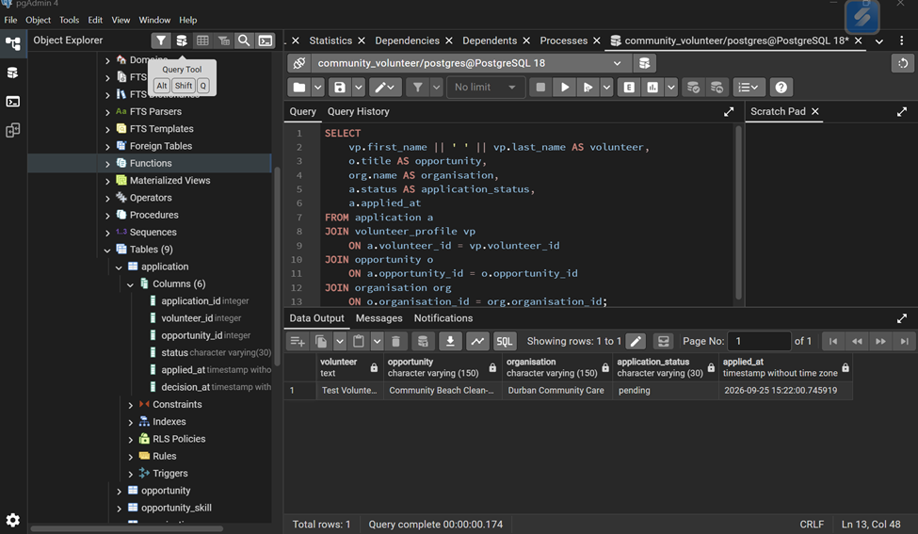
Figure 19: Multi-table Integration

Version-Control Integration Evidence
A specific branch and pull request were used to add the PostgreSQL database schema to the common GitHub repository. The database structure was made accessible to the rest of the development team and traceable integration evidence was provided when the pull request was merged into the main branch.
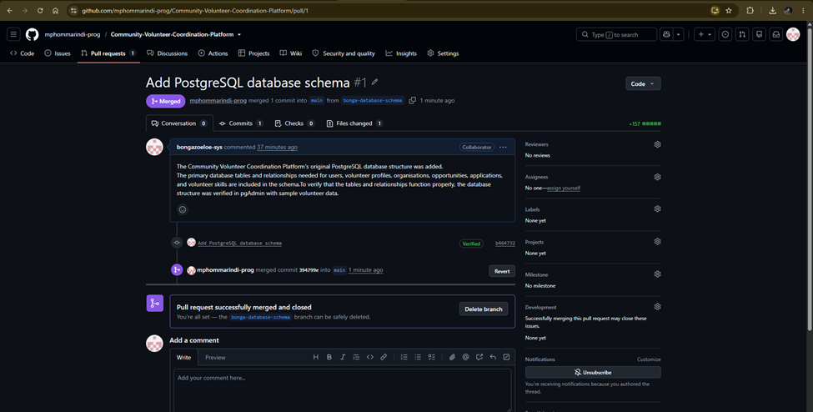
Figure 20: Version Control Integration Evidence

End-to-End Integration Flow
Table 4 Integration Flow
Step | System action | Component involved
1 | Volunteer opens the opportunities page. | Frontend
2 | Frontend requests opportunity data. | Frontend -> Backend/API
3 | Backend queries the Opportunity table. | Backend -> PostgreSQL
4 | Opportunity data is returned and displayed. | PostgreSQL -> Backend -> Frontend
5 | Volunteer selects Sign Up / Apply. | Frontend
6 | Backend validates the volunteer and opportunity of IDs and creates an application record. | Backend -> PostgreSQL
7 | The application is stored with a pending status. | PostgreSQL
8 | Administrator retrieves and later updates the application status. | Frontend -> Backend -> PostgreSQL

Current Integration Status
The database relationships have been independently confirmed, and the frontend and PostgreSQL database components have been implemented. Finalizing the backend API connection to enable frontend activities to automatically create, retrieve, and update PostgreSQL data is the last technical step. While complete end-to-end integration is still being worked on, the database tests offer confirmed component-level evidence until that demonstration is finished.

Technical Considerations
The group should make sure that backend queries use the same table and column names and maintain the PostgreSQL schema as the only database source of truth. Database credentials should be provided via environment variables or a local configuration file that is not subject to version control rather than being directly placed in the GitHub repository. Test password hashes used for verification are not production password hashes; rather, they are merely demonstration data.

6. Integrated Minimum Viable Product

6.1 System Integration Overview
- The frontend, backend, and database are fully connected. The public/js/app.js file sends requests using fetch ("/api/..."). These requests are handled by the Express routes, which call the appropriate service functions. The services then communicate with the MySQL database through the connection pool in db.js.
- All 14 endpoints listed in Section 5.2 have been implemented and connected to their respective service functions. There are no incomplete or placeholder endpoints.
- The database structure in sql/schema.sql contains all the tables and foreign-key relationships required by the SQL queries used in the services. For example, the JOIN between volunteer profile and opportunity in applicationService.js relies on the relationships defined in the database schema.
- Authentication is also integrated across the system using sessions. During login, authRoutes.js stores the user's id and role in req.session. The middleware/auth.js file then uses these session values to verify access to protected routes. Because the frontend and backend are hosted on the same origin, the browser automatically includes the session cookie with each request.

6.2 Step by step verification checklist
Table 5: Verification Checklist
Step | Command / action | Confirms
1 | npm install | package.json's five dependencies (express, express session, mysql2, bcryptjs, dotenv) resolve with no errors
2 | cp .env.example .env, then fill in MySQL credentials | db.js can build a valid connection config
3 | npm run db:migrate | scripts/migrate.js successfully runs sql/schema.sql — all 8 tables + indexes created
4 | npm start | server.js binds to :8080 with no startup errors
5 | Open http://localhost:8080 | public/index.html + css/style.css + js/app.js are served correctly; the login/register screen renders
6 | npm test | tests/flow.test.js passes registration, duplicate-email rejection, full apply/approve flow, capacity enforcement, role checks, unauthenticated rejection

6.3 Manual end to end demo script
Once the checklist has been successfully completed, the following step-by-step test can be used to confirm that the MVP is fully integrated and that the different components work together as one system:
1. Organization account: Register an organization account with the ORG_ADMIN role and log in. Select “Post Opportunity”, enter the opportunity title, description, location, start date/time, and set the available spaces to 1. Submit the opportunity.
2. Volunteer account: Open a separate browser or incognito window and register a volunteer account. Log in, select “Browse Opportunities”, find the opportunity created by the organization, and click “Apply.”
3. Approve the application: Return to the organisation account and open “My Opportunities.” Select “View Applications” and confirm that the volunteer's application appears with a PENDING status. Click “Approve” to accept the application.
4. Confirm acceptance and notification: Return to the volunteer account and refresh “My Sign-Ups.” The application's status should now be displayed as ACCEPTED. Then open “Notifications” and verify that a notification mentioning the opportunity by name has been received.
5. Test the capacity limit: Using a third account, try to apply for the same opportunity after it has reached its capacity. The application should be rejected with the message “This opportunity is now full.” This confirms that the capacity control mechanism described in Section 5.4 works correctly during actual system use and not only within the transaction logic.

6.4 Main Risk Areas to Check if the System Fails
- MySQL connection settings: The database configuration in. env is one of the first things to check when a problem occurs. If npm run db:migrate returns an ER_ACCESS_DENIED_ERROR, the DB_USER and DB_PASSWORD values should be checked first.
- dateStrings: true in db.js: This setting ensures that DATETIME values are returned as strings in the YYYY-MM-DD HH:mm:ss format, which matches the format expected by formatDateTime() in app.js. If dates appear as “Invalid Date” on the frontend, this setting should be checked.
- Session cookie configuration: The browser and server must be correctly configured to work with http://localhost during local testing. If the application is tested on a different domain or deployment environment, the session.cookie.secure and sameSite settings in app.js may need to be updated. Incorrect settings can cause the session cookie to be rejected, resulting in protected routes returning 401 NOT_AUTHENTICATED.

6.5 Current Limitations of the MVP
- No automated browser testing: The tests/flow.test.js file tests the API through HTTP requests using the Fetch API, but it does not interact with the actual frontend DOM in public/js/app.js. In a future version, a Playwright or Cypress test could be added to automatically perform the complete workflow described in Section 6.3.
- Global dateStrings: true setting: The dateStrings: true option applies to the entire database connection pool. While this works correctly for fields such as opportunity.start_datetime and application.applied_at, any future TIMESTAMP fields that need server-side sorting will need to be converted explicitly.
- In-memory session storage: The application currently uses the default MemoryStore provided by express-session. This is suitable for a single-process development environment, but sessions will be lost when the server restarts and cannot be shared between multiple processes. Before deploying the system publicly, a persistent session store such as MySQL or Redis should be considered.
- No CSRF tokens: State-changing routes do not currently use explicit CSRF tokens. The sameSite: "lax" cookie setting and same-origin frontend provide protection against cross-site POST requests during local testing. However, an explicit CSRF protection method, such as a double-submit cookie or synchroniser token, should be implemented before the application is deployed on a public domain.

6.6.MVP Completion and verification criteria
The increment can be considered complete once all steps in Section 6.2 have been successfully completed on a machine running a live MySQL server. The demonstration in Section 6.3 should also successfully show the complete process involving two users, from submitting an application to approval and notification, without requiring any manual changes to the database. The MVP should only be considered fully verified after this complete workflow has been tested successfully, rather than simply being considered finished because the code has been implemented.

7. Updated Documentation
The project documentation is being updated to reflect the development progress made since the previous submission. The previous documentation primarily described the proposed system design and user-interface prototype. The updated documentation records the implementation of the core prototype, the current system structure and the status of the functional requirements.
The system design documentation is revised to reflect the implemented components and any changes made to the original architecture. The requirements of traceability documentation is updated to identify which requirements have been implemented, partially implemented or remain outstanding.
A user guide is provided to explain the main functions available to Volunteers and Organization Admins. An installation and setup guide documents the software requirements, project structure and procedures for running the application. Where applicable, the documentation also includes database configuration and setup instructions.
Testing documentation records the test cases used to verify the core functionality, together with the expected results, actual results and test outcomes. Known limitations and outstanding features are documented to provide an accurate account of the prototype's current state.
These updates ensure that documentation remains consistent with the implemented system and provides the information required for future development, testing and maintenance.

Table 6: Requirement traceability
Requirement | Relevant component | Status
Users can log in | Login page / authentication | Update after testing
Admin can post opportunities | Post Opportunity | Update after testing
Volunteers can browse opportunities | Opportunities page | Update after testing
Volunteers can sign up | Opportunity Details | Update after testing
Volunteers can manage sign-ups | My Opportunities | Update after testing
Admin can view applicants | Applicants page | Update after  testing

8. Version Control, Defect Management and Development Discipline
To handle and coordinate the overall code development for this software we will utilize the development tool Git and GitHub. All team members will install the desktop tool and create accounts. This can be done with little to no complexity as the desktop application occupies low storage and the accounts can be created for free on Git, with access to sufficient tools/features for our software’s development. Git will require to work with a code editor or IDE for each user. Visual Studio Code was discussed to be the code editor that most members are comfortable with.

Therefore, Git/GitHub will offer a simple way to achieve version control, manage defects and errors and implement development discipline.

Report

Version Control

Version control of the system was overseen by Git and GitHub. These tools allow us to keep track of changes we make to our code and project files. We were able to create a few branches from the main code of the system due to time complexity. We were able to assign small tasks to each member of the group to add/update, while maintaining the original working code(main) intact. The first working code of the system was done through the integration of the parts that were assigned between us and got our first version of the system to append upon. Branches created were mini sections of the backend and database.
Below is the structure of the software code development being done on GitHub.
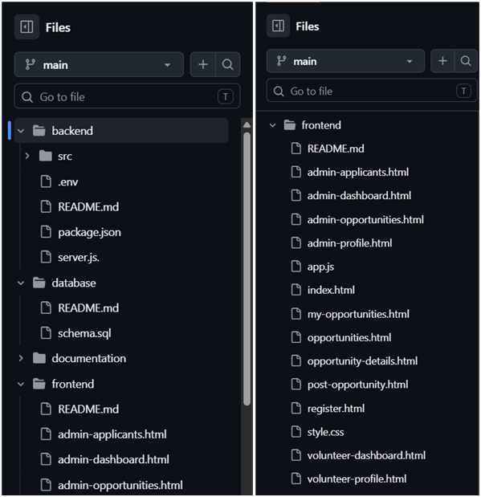
Figure 21: Software code
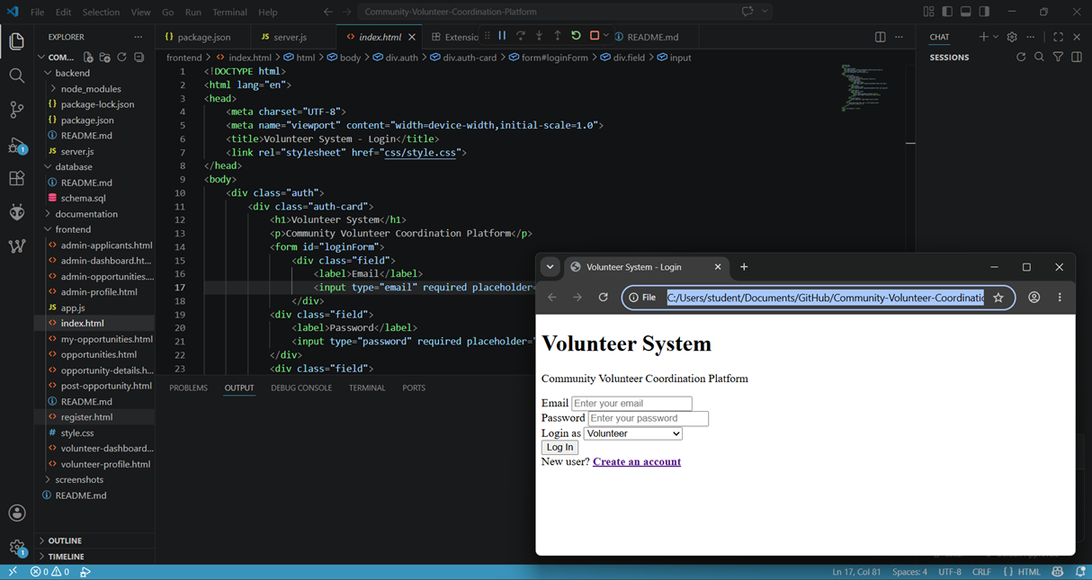
Figure 22: Community Volunteering Software: Version 0.1 (core prototype)
Increments of the system code (versions) are and will be kept in a safe folder on local storage for reference and record.

Defect Management

Using GitHub we will be able to collaborate our Git Projects and track changes. This makes it easier to review these changes and identify defects and errors. Each branch will be reviewed by one other group member for defects before using the pull requests feature to update and append our main code. This will be how we get our second version of the system.

Below are the defects and role assignment of the defects and their priority:
Table 7: Defect and role
Defect | Type | Assigned To | Priority
Registration form Validation | Front End | Koketso Ramakopa | Medium
Opportunity search | Front End | Mpho Marindi | Medium
Application UI | Front End | Banele Zwane | Medium
Authentication | Back End | Sbonelo Ngcobo | High
Database/Application processing | Back End | Bonga Zulu | High

Development Discipline

The system will be developed in increments and sections that will be split among the members. However, it will be vital that we maintain a single coding/development standard in our individual tasks.

Below is a summary of the development disciplines we will implements in our development of our community volunteering software:
Table 8: Development
Discipline | Details | Implementation
Coding Standards | Following consistent rules when writing code | Use consistent naming, indentation and structure (e.i camelCase)
Version Control | Keeping track of changes to the project | Save and track different versions of the code
Code Reviews | Checking another person's code before it is accepted | Team members review each other's work
Testing | Checking that the system works correctly | Test features before considering them complete
Documentation | Recording how the system works | Document code, APIs, database tables and design decisions
Defect Management | Finding, recording and fixing problems | Create defect records and assign them to team members
Task Management | Organizing and assigning project work | Divide tasks between team members and track progress
Regular Backups | Preventing loss of project work | Keep copies of important project files

9. Reflection and Technical Debt
- Requirements Engineering
We learned the importances of creating persona, user stories and acceptance criteria as it guided us to what exactly we wanted our system to do. This carried over to code development as we had a clear goal and understanding of the software’s scope. However, in future we would also benefit to making sure the requirements discussed are within feasibility considering the project complexities and development environment.

- Code development
During code development, we learned the importance of dividing the system into smaller components and assigning tasks to different team members. Using consistent coding practices made it easier to combine everyone's work. We experienced some problems when integrating different parts of the system, especially when frontend and backend components did not communicate correctly. We also learned that familiarizing ourselves with Git and GitHub would be in our best interest for future projects. We should also integrate and test components more regularly instead of waiting until the end.
- Report Management
We learned that keeping the report organized throughout the project will make the final submission easier. Each team member contributed different sections, but combining these sections sometimes resulted in differences in formatting and writing style, especially since we used online word documents throughout the project where each member copy and paste from their work, they did individually. We would improve this by using a common structure and reviewing the report as a team. In future, we will update the report continuously as the project progresses rather than completing most of it near the deadline.

Conclusion
The primary framework needed for organizing volunteers and organizations is effectively established by the Community Volunteer Coordination Platform. A PostgreSQL database for storing and managing system data, frontend interfaces for volunteers and administrators, and backend functions for linking the user interface to the database comprise the implemented system. Important elements including users, volunteer profiles, organizations, opportunities, talents, and applications can be saved and associated effectively, according to database testing. Multi-table searches and relationship testing also showed that the database's components function as planned. During development, version control and team collaboration were further aided by the use of GitHub. The existing solution offers a solid foundation for the Minimum Viable Product and for future platform development, even if final frontend, backend, and database integration still require full end-to-end verification.

References
[1] How to Create a Pull Request in GitHub - GeeksforGeeks
[2] How To Create a Pull Request With GitHub Desktop
[3]How to Use Git and GitHub – a Guide for Beginners and Experienced Developers
[4] Elmasri, R. and Navathe, S.B. (2016) Fundamentals of Database Systems. 7th edn. Harlow: Pearson.
[5] Sommerville, I. (2015) Software Engineering. 10th edn. Harlow: Pearson.
[6] PostgreSQL Global Development Group (2026) PostgreSQL 18 documentation. Available at: https://www.postgresql.org/docs/18/ (Accessed: 22 September 2026).
[7] GitHub (2026) About pull requests. Available at: https://docs.github.com/en/pull-requests (Accessed: 23 September 2026).
[8] OWASP Foundation (2026) Password Storage Cheat Sheet. Available at: https://cheatsheetseries.owasp.org/cheatsheets/Password_Storage_Cheat_Sheet.html (Accessed: 25 September 2026).

